【主日事工分配】Sunday Service Personnel
日期Date | 11/27感恩早午英三堂聯合崇拜 | 12/04/16早堂 | 12/04/16午堂
證道Sermon | 尤陽生牧師Pastor Yu | 尤陽生牧師 | 尤陽生牧師
司會Presider | 簡英仁Eric Chien  Alanna Bethon | 潘巨明 | 鍾仁賢
領詩Singing Leaders | 聯合敬拜團隊  Joint Praise Team | 曹大為/黃文華  戴佳/劉淑清 | 張哲雄  邵順秀  徐惠敏
司琴Pianist | 張美琴Megan Chang | 尤立馨 | 劉淑瓊
司獻Offertory | 薛婉華Angela Hsueh | 周娟娟 | 蔡秀美
招待Usher  點名Attandance | 王積惠Emily Wang  洪紅美Amy Hung | 周娟娟  董芬芳 | 蔡秀美  張巧幸
歡迎Welcome | 蔡嘉儀Isabel Choi | 董芬芳 | 張巧幸
投影片PPT | 陳元卿Ann Chen | 周賢忠 | 林振成
音響燈光Sound | EM | 許揚 | 童敏益
獻花Flora | 張寧生Jeannes Chang | 唐耀鴻 | 唐耀鴻
【教會聚會表】Church Schedule
聚會內容Worship/Meeting | 聚會日期Day | 聚會時間Time | 負責/聯絡人  Contact | 電話Telephone
早堂華語崇拜  Mandarin Worship | 週日Sun | 9:30am | 劉淑清姐妹  Samantha Liu | 516-791-2313
午堂台語崇拜  Taiwanese Worship | 週日Sun | 11:00am | 劉淑清姐妹  Samantha Liu | 516-791-2313
英文崇拜  English Worship | 週日Sun | 12:30pm | 白書亞牧師  Pastor Joshua Birchfield | 970-689-2671
兒童崇拜Children S.S. /Worship  兒童主日學 | 週日Sun | 9:30分班/10:45合班12:00分班 | 張美琴姐妹  Megan Chang | 917-566-9006
成人主日學  Adult S.S. (早/午堂) | 週日Sun | 早-11:00am  午-12:30pm | 陳元卿姐妹  Ann Chen | 347-834-4121
英文主日學Eng. Sunday School | 週日Sun | 11:00am | 陳鴻成弟兄  Daniel Chen | 646-267-3815
詩班練習  Choir Practice | 週日Sun | 2:00pm | 劉淑清姐妹  Samantha Liu | 516-791-2313
電話祈禱網  禱告會Prayer  禱告會Prayer | 週二Tue  週三Wed  週末Wknd | 9:00-9:50pm  8:00pm  (時間另訂) | 撥712-432-0075  楊自豪弟兄(教會)  尤陽生牧師(教會) | 密碼141852#  646-823-5359  718-746-4199
英文青少年團契  Keystone Youth Group  大學社青College/Career | 週五Fri  週五Fri | 8:00pm  8:00pm | Samantha Yu  Bridgeen Yap  陳鴻成弟兄Daniel | 646-673-3946  347-326-2799  646-267-3815
弟兄團契Brother F. | 不定期 | TBA | 戎嗣定弟兄 | 718-216-5018
姊妹團契Sister F. | 不定期 | TBA | 劉淑瓊姊妹 | 718-808-3859
基督教紐約聖教會週報

Queens Taiwanese Evangelical Church
第48週 主後AD 2016年11月27日

年度主題 Theme of the Year
《操練生命，委身使命》
Discipline Life, Devote to Great Commission
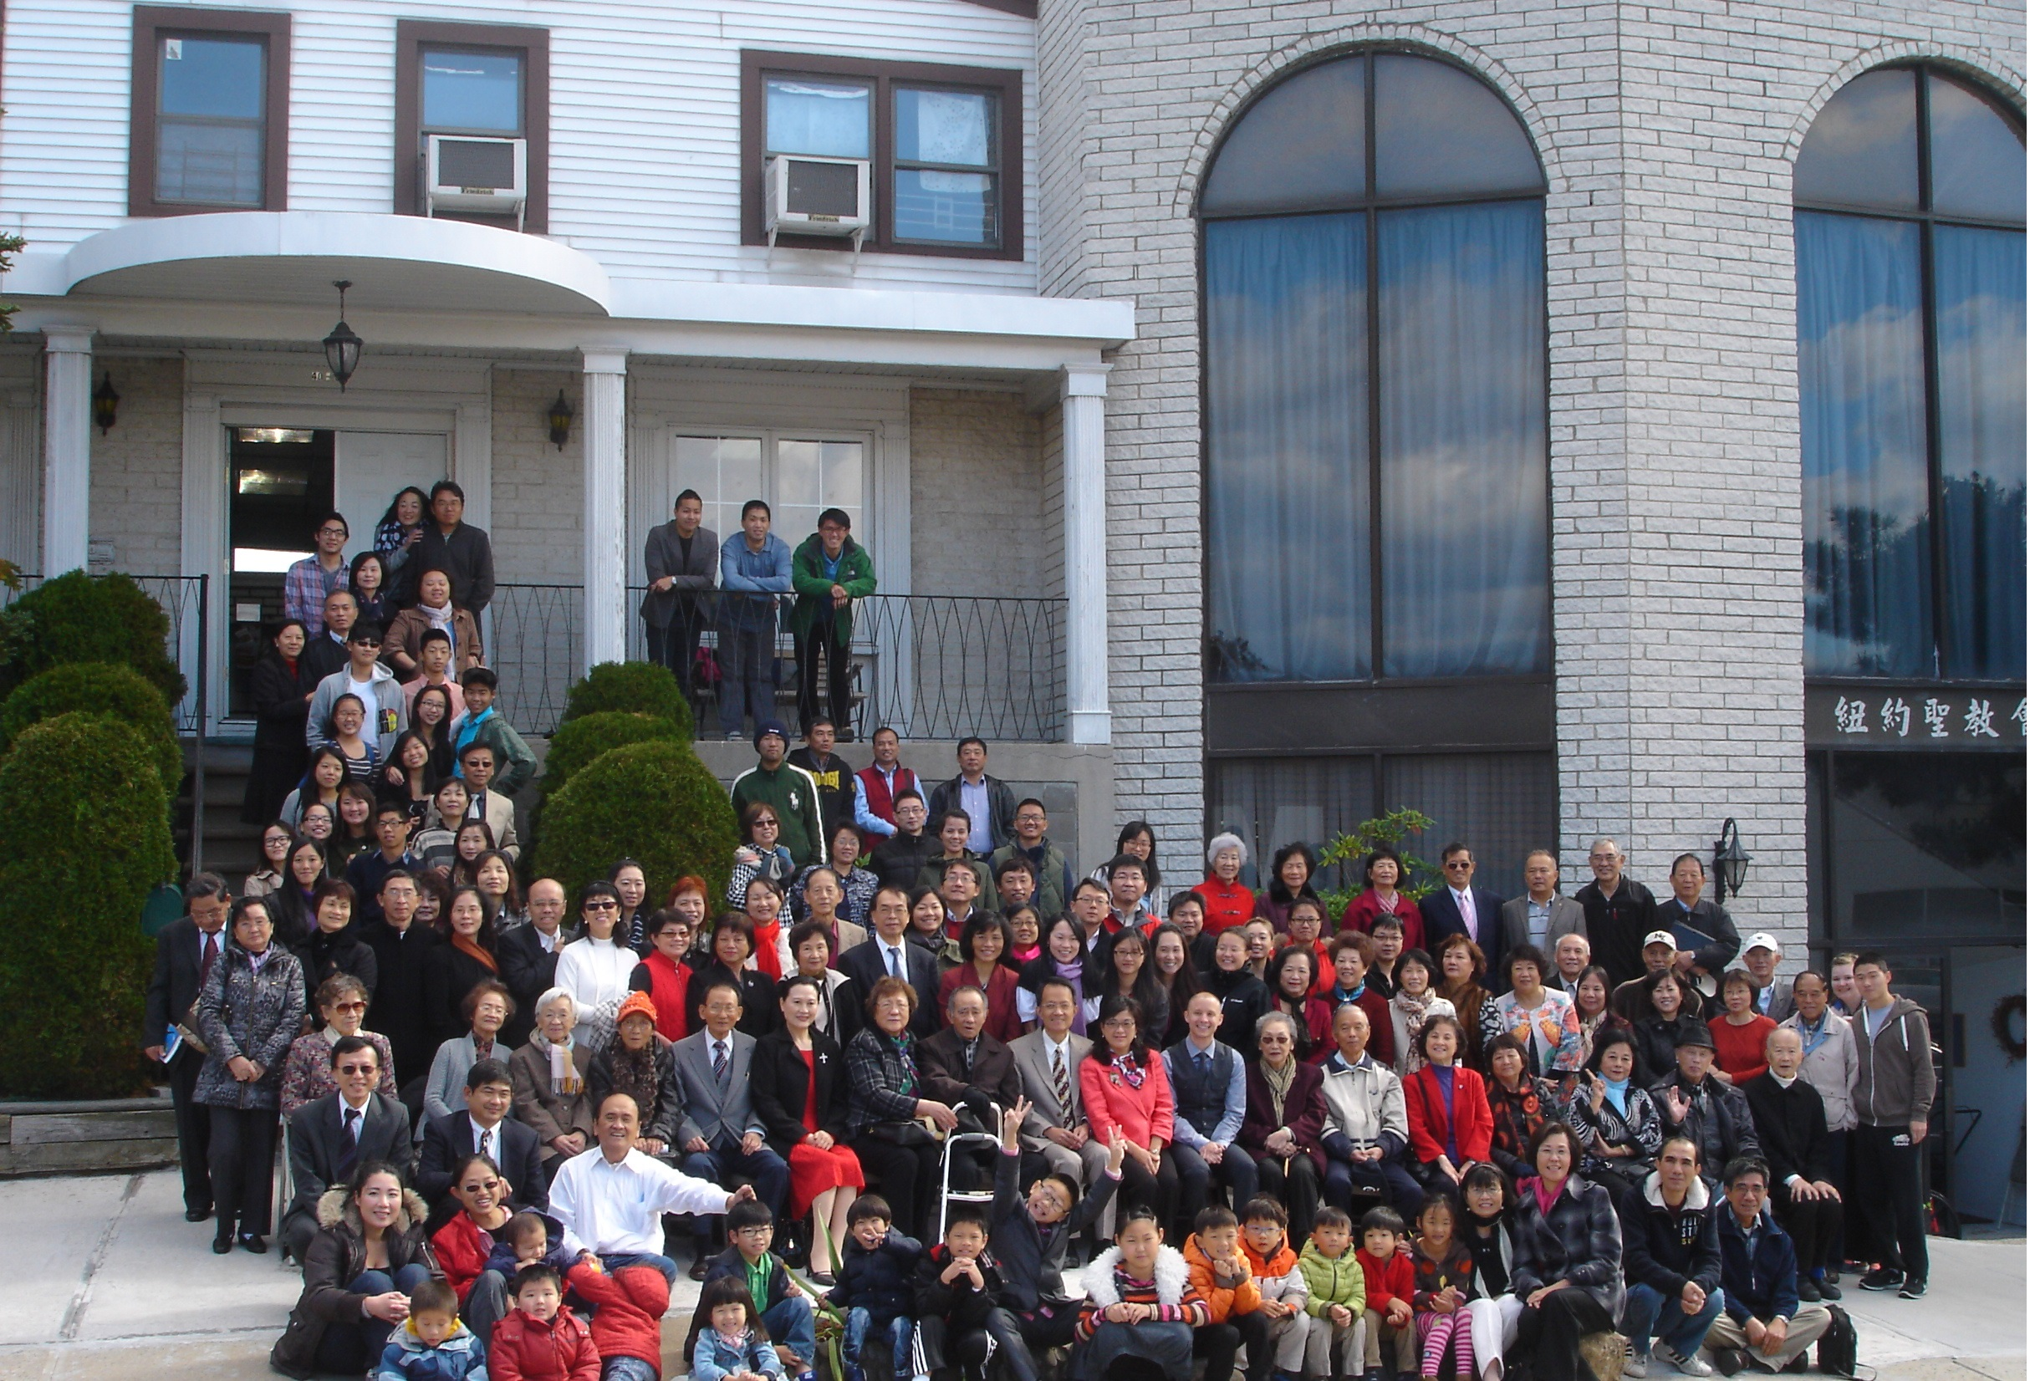
年度金句Key Verse of the Year
提摩太前書1 Timothy 4:8 / 以賽亞書Isaiah 54:2
「因為操練身體，益處還少；唯獨操練敬虔，凡事有益，享有今生和來世的應許。」/「要擴張你帳幕的地方，伸展你居所的幔子，不要限制；
要拉長你的繩索，堅固你的橛子。」(聖經新譯本)
「操練身軀有淡薄利益，口毋拘敬虔對逐項攏有利益，因為有現今及將來活命的應允。」/「著開闊你布棚的地，放大你徛起的帳幅，呣通限定；
著牽長你的索，堅固你的杙仔(khít-á)。」(現代台語譯本)
“For while bodily training is of some value, godliness is of value in every way, as it holds promise for the present life and also for the life to come.”/“Enlarge the place of your tent, and let the curtains of your habitations be stretched out; do not hold back; lengthen your cords and strengthen your stakes.” (ESV)
榮譽牧師Pastor Emeritus：高耀民牧師Rev. Benjamin Kao
主任牧師Senior Pastor：尤陽生牧師Rev. Johnson Yu Tel:718-746-4199
英語牧師English Pastor：白書亞牧師Rev. Joshua Birchfield Tel:970-689-2671
值月同工Coworker of month：張美琴姐妹Megan Chang Tel:917-566-9006
教會地址Church Address：40-31 165th Street, Flushing, NY 11358
教會電話Church Tel：(718)460-6326 教會網址: qtecny.wtc.net
紐約聖教會〔感恩節主日〕聯合禮拜10:00am
QTEC Thanksgiving Sunday Combined Worship
第48週 2016年11月27日

司會:簡英仁弟兄 / Alanna姊妹 司琴:張美琴姊妹
Presider: Eric Chien / Alanna Bethon Pianist: Megan Chang

序樂/Prelude………(會眾安靜默禱 Prayer in Silence)………司琴Pianist
宣召/Call to Worship………………………………………司會Presider

讚美/Songs of Praise…………………聯合敬拜團隊Joint Worship Team
1.「將天敞開」"Open Heaven"
2.「耶穌，謝謝祢！」"Jesus, Thank you!"
禱告/ Prayer…………………………………… 敬拜團隊Praise Team
主禱文/Lord’s Prayer…………………………………會眾Congregation
獻詩/Anthem ……………………………………教會詩班Church Choir
「祂醫治我的心Healer of My Heart／來讚美耶和華Laudate, Praise The Lord」
讀經/Scripture Reading…「腓Phil.4:6,8-9；詩Ps.100:4；帖前1Thess 5:16-18」
短講/Message………《感恩是喜樂與美善之母》………………尤牧師
"Gratitude Is the Mother of Happiness and Goodness" Pastor Yu

奉獻/Offertory……「感謝神」 (世紀頌讚308首)……薛婉華姐妹Angela Lo
“Thanks to God for My Redeemer” (Century Praise #308) Christine Li李婷姐妹
(若你還不瞭解奉獻意義請不必奉獻 Please refrain from offering if you do not understand the meaning)

頌榮/Doxology…………「讚美宇宙主宰」(聖歌30)」……會眾Congregation
"Come Thou Almighty King"
祝禱/Benediction………………………………………尤牧師Pastor Yu
阿們/Amen…………………「阿們頌Amen」………會眾Congregation
殿樂/Postlude…………(會眾安靜默禱Prayer in Silence)……司琴Pianist
～～～～～～～～～～～～～～～～～～～～～～～～～
金句:（帖前1 Thess.5:18）
(華)「在任何環境中都要感謝，因為這是上帝在基督耶穌裡向你們
所定的旨意。」
(台)「無論甚麼境遇攏著(lóng tio̍h)感謝，因為這是上帝的旨意，
要恁(ài lín)這些( chiah-ê)屬基督耶穌的人安呢(án-ne)做。」
(Eng.) “Give thanks in all circumstances; for this is the will of God
in Christ Jesus for you.”
歡迎及消息報告Welcome and Announcement…………………司會

【紐約聖教會-各團隊負責同工】Church Co-worker Team
團隊Team | 同工Coworker | 聯絡電話Contact
主席Chairperson | 尤陽生牧師Rev. Johnson Yu | 718-746-4199
副主席Vice Chair | 陳鴻成Daniel Chen | 646-267-3815
英語牧師EM Pastor | Rev. Joshua Birchfield白書亞牧師 | 970-689-2671
行政Administration | 陳鴻成Daniel Chen  尤立忠Jeffrey Yu | 646-267-3815  646-673-4088
敬拜Worship | 劉淑清Samantha Liu | 516-791-2313
關懷Caring | 陳天忠Tian Zhong Chen | 917-832-3598
造就Discipleship | 陳元卿Ann Chen | 347-834-4121
事奉Service | 張文雄Wen-Hsiung Chang | 718-380-7553
宣教Mission | 潘巨明James Pan | 718-359-4096
財務Finance | 黃文華Ann Huang | 917-678-1536
英語部English Ministry | 李婷Christine Li | 718-640-3181
兒童部Children Ministry | 張美琴Megan Chang | 917-566-9006

【小組聚會】Chinese Small Groups
僕人 | 聚會時間 | 聚會地點 | 聯絡電話
長輩喜樂小組-張文雄夫婦 | 週二10:00am | 40-32 166th Street -社區中心 | (646) 427-7040
週五小組/每週聚會 | 週五8:00pm | 40-31 165th Street -教會一樓 | (718) 460-6326
社青小組-朱世杰夫婦 | 週五7:30pm | 40-31 165th Street -教會三樓 | (917) 566-8602
週六小組/每月一、三週 | 週六4:00pm | 40-31 165th Street -教會三樓 | (718) 460-6326
桌球練習-林振成弟兄 | 週一,三8-10pm | 週六2-6 pm -教會一樓 | (917) 754-8503

【2016年十月早、午堂主日學】Mandarin/Taiwanese Sunday School
班別 | 老師 | 教室
早堂:慕道班 | 朱駿康/王曉暉 | 三樓客廳
初信造就班 | 黃文華/劉淑瓊 | 一樓A教室
信徒造就班 | 孫瑞松/陳元卿 | 一樓餐廳
午堂: 信徒造就班 | 簡英仁/周清芬/鍾仁賢 | 三樓客廳
【11/20/16主日聚會人數】Attendance
早堂崇拜 | 午堂崇拜 | 英文堂崇拜 | 兒童部崇拜 | 合計人數
人 | 31人 | 32人 | 兒童:19人/成人:6人 | 人
【11/13/2016主日奉獻明細及總計】Offertory Details
十一奉獻  Tithe | #45:$145/#269:$20/#286:$200/#257:$100/#265:$100#31:$20  YHH:$30/#270:$20/#50:$100/#220:$20/#57:$800/#219:$200  #282:$20/#53:$10/#97:$40/#87:$40/#72:$30#275:$5/#236:$20  #205:$200/YYY:$200/ZP:$5/#44:$20
感恩奉獻Thanks | #210:$50/#103:$400/#56:$5/ZC:$10/#280:$20/#285:$30
建堂奉獻  Build | #277:$50/#55:$400/#264:$150/有志:$20/LCM:$20/#280:$500
其他奉獻Misc. | #234:$20(關懷)////$192(蛋糕班)
現金奉獻Cash | 十一奉獻 | 感恩奉獻 | 建堂奉獻 | 其他奉獻 | 奉獻總計
$558.00 | $3,225.00 | $430.00 | $570.00 | $250.00 | $5,103.00

第48週 11/27/2016 值月同工: 張美琴Coworker of the Month: Megan Chang

【歡迎與消息報告】Welcome and Announcement
- 歡迎新朋友及過訪的主內兄姊，願神賜恩於你，請繼續來認識敬拜神。

□〔教牧/同工團隊〕Pastoral and Co-worker Team
- 為受洗的神國新人獻上感恩及歡迎:11/26有:劉馨，薛維娜，朱青，任安妮，宋明貴；11/20英文部王禕，共六位弟兄姊妹。請為他們代禱，能在基督裡靈命繼續成長，成為主的門徒。
- 今天中、英文各級主日學都停課，聚會後請留步到一樓用午餐。
- 2017教會月曆一家一份，請在招待處簽名領取。
- 請繼續為建堂需要關心與奉獻支持：
募款總目標  Pledge Goal | 已收奉獻累計(至11/13)  Cumulated Received (11/13) | 台灣募款(至11/20)  Fund Raising-Taiwan(till 11/20) | 總計還需奉獻  Pledge Still Needed
$980,000 | $404, 420 | $52,288 | $521,612

銀行貸款每月還款  Monthly Mortgage | 本月累計奉獻(至11/13)  Received This Month (Till 11//13)
$2,800 | $1,710
- 教會徵聘一位〈半職教牧幹事〉以分擔牧者事務性工作。資格要求與工作內容詳情貼於佈告欄，合乎條件有負擔者請直接與尤牧師聯繫。
□〔敬拜〕Worship
- 詩班今天不練唱。
□〔宣教/社區外展〕Mission/Community Outreach
- 12/11(日)在本會有台灣早期童星「紀寶如姊妹詩歌生命見證會」，當天上午10:00-12:00早、午堂聯合崇拜，會後主日小組延後一週。
- 基督使者協會「2016華人差傳大會」將於12/27-31 (二-六)在巴爾的摩會議中心舉行。目前本教會共14位報名參加，報名12/12截止，請洽鍾仁賢弟兄(201-655-0968)或周清芬姊妹(201-390- 6435)。
- 教會社區展望中心課程:
- 「兒童音樂學校」"QTEC Music School"，費用:$300。每週六A班: 10-11am，B班:2-3pm。時間:10/22/2016～1/21/2017共11堂課，歡迎家中有3-6歲孩童報名參加。詳情請看佈告欄海報。
˙網上報名: https://www.facebook.com/qteccommunitycenter/?fref=ts
- 教會〈社區展望中心〉所開的各種日間學習班，徵求多位義工來輪
流擔任教師助手。請洽宣教同工潘巨明弟兄(718-359-4096)。
□〔關懷/肢體聯繫〕Caring/Fellowship Connection
- 請記念志偉弟兄的身體，11/23因身體不適，緊急入院，請代禱。
- 恭賀Angela 和Rex 在11/24感恩節喜得一女，母女均安，女兒取名Lydia，我們一起分享他們的喜悅。
- 梅小潔母親沈嬡娥女士在11/24週四下午安息主懷，求主安慰小潔及遺族家屬。
- 身體欠安：董仲天(董芬芳父親中風)，周文耀，簡如詳，高牧師，周震歐，劉馨，王志偉，葉元龍，陳蓉，戎嗣定，鄭建民，陳許秀鳳，薛盧瑞英，郭淵源，郭久美，劉忠彥，張少杰，郭秀卿，洪傳雄，謝熊聯芳，張董繼璜，韓王桂枝，郭振玉，鄭賢堅。

第48th wk週 11/27/2016 紐約聖教會主日崇拜
講題：《感恩是喜樂與美善之母》 尤陽生牧師
"Gratitude Is the Mother of Happiness and Goodness" Pastor Yu
經文：腓Phil.4:6,8-9；詩Ps.100:4；帖前1Thess 5:16-18

【2016年十二月聚會及活動】
日期Date | 時間Time | 活動內容Activities | 連絡人Contact | 聯絡電話TEL
12/04 | 各堂時間 | 聖餐主日 | 劉淑清Samantha Liu | (718)938-2796
12/24 | 7:30pm | 聖誕夜福音晚會 | 劉淑清Samantha Liu | (718)938-2796
12/25 | 10:00am | 中英三堂聖誕聯合崇拜 | 劉淑清Samantha Liu | (718)938-2796
12/27-31 | N/A | 2016使者差傳大會 | 潘巨明James Pan | (718)359-4096
12/31 | 10:30pm-  12:15am | 跨年禱告會 | 劉淑清Samantha Liu | (718)938-2796

48th week 11/27/2016 Coworker of the Month: Megan Chang

＊Welcome and Announcement
- We welcome the new friends and visitors. We hope you will come again to know and worship God with us. May God bless you.

□Pastoral and Co-worker Team
- Let's give thanks for and welcome the new persons of God's Kingdom in Christ who were baptized on last night 11/26: Xin Liu, Wei Na Xue,Judy Zhu, Annie Ren, Ming Kuei Song; plus Yi Wang from English Ministry baptized on last Sunday 11/20. Please pray for their continuing spiritual growth in Christ to be His disciples.
- Today’s Chinese and English Sunday school classes are all cancelled. Lunch will be served after the worship. You are invited to stay and have fellowship with us.
- 2017Church Calendar has arrived, one for each family. Please sign up and take it at reception desk.
- Please continue to pray for and support our need for church building mortgage:
Pledge Goal | Cumulated Received (11/13) | Fund Raising-Taiwan(till 11/20) | Pledge Still Needed
$980,000 | $404, 420 | $52,288 | $521,612

Monthly Mortgage | Received This Month (Till 11//13)
$2,800 | $1,710
- QTEC is recruiting a part time pastoral secretary to assist pastors of weekly routines. Please contact Pastor Yu for details.
□〔敬拜〕Worship
- There is no Choir Practicing today.
□Mission/Community Outreach
- There will be a "Life Testimony" by former child star sister Bo-Ru Chi from Taiwan on Dec. 11, Sun., 10 A.M. with CM/TM combined service.
- "2016 AFC Chinese Mission Convention" will be held at Baltimore Convention Center on Dec. 27-31, Tue.-Sat. So far there are 14 from QTEC registered. Deadline is Dec.12. Please contact James Pan.
- QTEC Community Outreach Center courses offered:
A."QTEC Music School"，fee:$300。Every Saturday: Class A at 10-11am,
Class B at 2-3pm。Period: 10/22/2016～1/21/2017 with 11 sessions in
total. Children at age 3-6 are welcome. See poster for details.
˙Web page: https://www.facebook.com/qteccommunitycenter/?fref=ts
- QTEC Community Outreach Center is recruiting volunteer teaching assistants for week day classes. Please contact James Pan (718-359-4096). □Caring/Fellowship Connection
- Please remember brother Chih Wei Wang in your prayer, who was hospitalized on Nov. 23 due to breathing difficulty.
- Congratulation to Angela & Rex, Angela gave birth to a baby girl Lydia on Nov. 24.
- The mother of former QTEC member sister Kathy Mui passed away on Nov. 24 at age 88. Please keep her in your prayer before the Lord.
- Pray for the sick and weary: Zhong-Tian Dong, Larry Zhou, Ju-Siang Chien, Rev. Benjamin Kao, Chen-Ou Chou, Xin Liu, Chih-Wei Wang, Regis Yieh, Nancy Chen, Si-Ding Rong, Chien-Min Cheng, Hsiu-Fong Chen, Jui-Ying Hsueh, Yuen-Yuen Kuo, Julie Kuo, Chung-Yen Liu, Shao-Jie Zhang, Hsiu-Qin Guo, Chuan-Hsiung Hung, Lian-Fang Hsieh, Ji-Huang Chang, Kuei-Ji Han, Zhen-Yu Guo, Xian-Jian Zheng.

Sermon: "Gratitude Is the Mother of Happiness and Goodness" Pastor Yu
Scripture: Phil.4:6,8-9; Ps.100:4; 1Thess 5:16-18
Note:

Services and Activities for December 2016
Date | Time | Activities | Contact | TEL
12/04 | Each Service | Communion | Samantha Liu | (718)938-2796
12/24 | 7:30pm | Christmas Eve Gospel N. | Samantha Liu | (718)938-2796
12/25 | 10:00am | Christmas Sunday | Samantha Liu | (718)938-2796
12/27-31 | N/A | 2016 CMC | James Pan | (718)359-4096
12/31 | 10:30pm-  12:15am | New Year's Eve Vigils | Samantha Liu | (718)938-2796

