【主日事工分配】Sunday Service Personnel
日期 | 9/23早/午/英/兒四堂聯合崇拜 | 9/30早堂崇拜 | 9/30午堂崇拜
證道 | 白書亞牧師Pastor Birchfield | 尤陽生牧師 | 尤陽生牧師
司會 | 朱世杰/Christine Li李婷 | 張文雄 | 簡英仁
領詩 | 英語部讚美團隊  EM Praise Team | 曹大為/王秀華  黃文華 | 張哲雄/黃美玲  邵順秀
司琴 | Samantha Yu尤立馨 | 張美琴 | 洪莉玲
司獻 | 王積惠/Yaojia Qu屈耀佳 | 顧芬怡 | 張麗珍
招待  點名 | 蘇純淑  王積惠 | 陶惠庭  王秀華 | 張麗珍  張巧幸
歡迎隊 | 張寧生 | 顧芬怡 | 張巧幸
投影片 | 曹大為 | 曾錦秀 | 林振成
音響燈光 | Charles Lin林家志 | 曾錦秀 | 林振成
獻花 | 鄭蓓莉 | 洪紅美 | 洪紅美
午餐服事 | 黃維靖 |  | 張巧幸
【教會聚會表】Church Schedule
聚會內容Worship/Meeting | 聚會日期Day | 聚會時間Time | 負責/聯絡人  Contact | 電話Telephone
早堂華語崇拜  Mandarin Worship | 週日Sun | 9:30am | 劉淑清姐妹  Samantha Liu | 718-938-2796
午堂台語崇拜  Taiwanese Worship | 週日Sun | 11:00am | 劉淑清姐妹  Samantha Liu | 718-938-2796
英文堂崇拜  English Worship | 週日Sun | 12:30pm | 白書亞牧師  Pastor Joshua Birchfield | 970-689-2671
兒童崇拜Worship  兒童主日學Children S.S. | 週日Sun | 9:30 教室開門  10:45合班崇拜12:00分班上課 | 張美琴姐妹  Megan Chang | 917-566-9006
成人主日學  Adult S.S. (早/午堂) | 週日Sun | 早-11:00am  午-12:30pm | 朱駿康弟兄  Richard Chu | 646-255-2268
英文主日學E.S.S.  青年團契Youth S.S. | 週日Sun | 11:00am | 陳鴻成Daniel Chen  Samantha Yu尤立馨  Bridgeen Yap葉麗薇 | 646-267-3815  646-673-3946  347-326-2799
詩班練習  Choir Practice | 週日Sun | 1:30pm | 劉淑清姐妹  Samantha Liu | 718-938-2796
電話祈禱網Phone  禱告會Prayer Meeting | 週二  週三 | 9:00-10:00pm  6:00-8:00pm | 撥712-432-0075  尤陽生牧師 | 密碼141852#  718-746-4199
英文青年團契  Keystone Youth Group  大學社青College/Career | 週五  週五 | 8:00pm  8:00pm | Samantha Yu尤立馨  Bridgeen Yap葉麗薇  陳鴻成Daniel Chen | 646-673-3946  347-326-2799  646-267-3815
弟兄團契Brother F. | 不定期 | TBA | 王焱南弟兄 | 917-960-6479
姊妹團契Sister F. | 不定期 | TBA | 王曉暉姊妹 | 646-705-1285

基督教紐約聖教會週報

Queens Taiwanese Evangelical Church
第38週 主後AD 2018年9月23日

年度主題 Theme of the Year
《穿戴全副屬靈軍裝，開展教會的新境界》
“Take Up Whole Armor of God to Advance Church's New Realm”

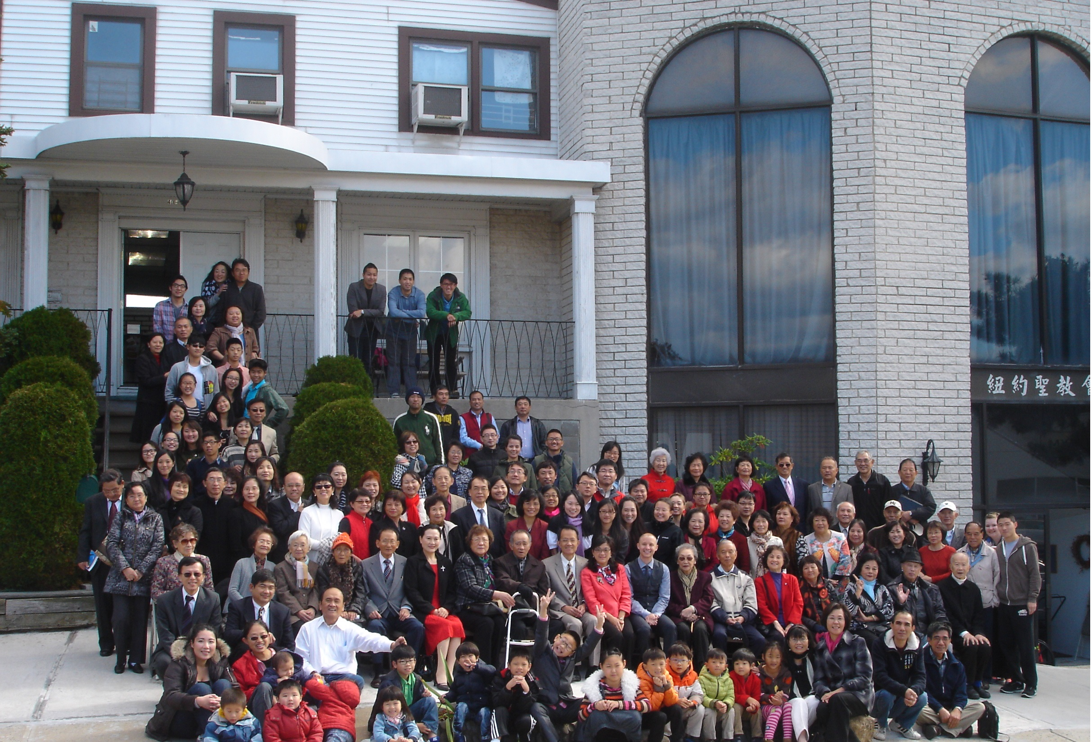

年度金句Key Verse of the Year
以弗所書Ephesians 6:13
「要穿起 神所賜的全副軍裝，使你們在這邪惡的時代裡可以抵擋
得住，並且在作完了一切之後，還能站立得穩。」 (新譯本)
「著穿上帝所賜全副的戰甲，通佇邪惡的日子會當抵抗對敵的攻擊，
戰鬥到底，徛在(khiā chāi)守住(siú-tiâu)陣地(tīn-tē)。」(全民台語)
“Take up the whole armor of God, that you may be able to withstand
in the evil day, and having done all, to stand firm.” (ESV)

榮譽牧師Pastor Emeritus：高耀民牧師Rev. Benjamin Kao
主任牧師Senior Pastor：尤陽生牧師Rev. Johnson Yu, Tel:718-746-4199
英語牧師English Pastor：白書亞牧師Rev. Joshua Birchfield, Tel:970-689-2671
值月同工Coworker of Month：劉淑清Samantha Liu, Tel: 718-938-2796
教會地址Church Address：40-31 165th Street, Flushing, NY 11358
教會電話Church Tel：(718)460-6326原網址:qtecny.wtc.net 新網址:qtecnyc.org

紐約聖教會〔兒童主日〕全體聯合禮拜
QTEC Children’s Sunday All Combined Worship Service
第38th wk週 2018/09/23 10:00 AM
司會:朱世杰弟兄/李婷姊妹 翻譯: 陳鴻成弟兄 司琴:尤立馨姊妹
Pres.: Scott Chu /Christine Li Trans.: Daniel Chen Pianist: Samantha Yu

序樂/Prelude……(會眾安靜默禱 Prayer in Silence)………司琴 Pianist
宣召/Call to Worship………………………………………… 司會Presider
讚美/Songs of Praise……………………英語敬拜團隊EM Praise Team
1.「榮美的救主 Beautiful Savior」 2.「憂痛的人 Man of Sorrows」
牧禱/ Pastoral Prayer………………………… Pastor Johnson Yu尤牧師
讀經一/Scripture Reading1……「弗Eph. 6:1-3; 箴Prv. 22:6」………
(E英): Adam Chu朱壽文; Edison Lee李翊瀚
(M華): Bryce Tsao曹以方；(T台): Austin Huang黃傑泰
獻詩/Praise……「世界之光/ Light of the World」…………兒童Children
與孩子共話/Words for Children…………Pastor Joshua Birchfield 白牧師
為畢業生禱告/Prayer for Graduates…………Pastor Joshua Birchfield 白牧師
1.小學到初中Elementary to Middle:…Renna Chang張芮涵; Ethan Wang王逸辰
2.兒童到英語部Children M to EM:…Aaron Chu朱壽恩; Austin Huang黃傑泰
讀經二/Scripture Reading2……「太Mt.18:2-4」…………………司會Presider
證道/Sermon………「像小孩子」“Childlike”………Rev. Birchfield白牧師
奉獻/Offertory………「耶穌愛我」………Emily Wang王積惠姐妹
"Jesus Loves Me" (生命聖詩Hymns of Life 513) & Yaojia Qu 屈耀佳姐妹
(若你還不瞭解奉獻意義請不必奉獻 Please refrain from offering if you do not understand the meaning)
頌榮/Doxology………「普天之下萬國眾生Doxology」(聖歌Hymns29)」……會眾
祝禱/Benediction…………………Pastor Birchfield白牧師/ Pastor Yu尤牧師
阿們/Amen………………「阿們頌Amen」……………………會眾
殿樂/Postlude………(會眾安靜默禱Prayer in Silence)……………司琴
～～～～～～～～～～～～～～～～～～～～～～～～～～～～～～
金句key Verse:（太Mt.18:4）[M:新譯CNV/ T:全民台語APT/ E:ESV]
(華M)「所以，凡謙卑像這小孩子的，他在天國裡是最大的。」
(台T)「所以，人若謙卑親像此個囝仔，伊佇天國就是上大的。」
(英E) " Whoever humbles himself like this child is the greatest in the kingdom of heaven."

歡迎及報告/Welcome & Announcements ……………司會Presider
教會合一禱告會-全體會眾/ Congregational Prayer for Church Unity

【紐約聖教會-各團隊負責同工】Church Co-worker Team
團隊Team | 同工Coworker | 聯絡電話Contact
主席Chairperson | 尤陽生牧師Rev. Johnson Yu | 718-746-4199
副主席Vice Chair | 陳鴻成Daniel Chen | 646-267-3815
英語牧師EM Pastor | Rev. Joshua Birchfield白書亞牧師 | 970-689-2671
行政一Administration 1  行政二Administration 2 | 唐耀鴻Yea Hung Tang  朴真善Jin Parque | 646-309-2997  516-806-0049
敬拜Worship | 劉淑清Samantha Liu | 718-938-2796
關懷Caring | 王積惠Emily Wang  王曉暉Julia Hu | 646-595-6996  646-705-1285
造就Discipleship | 朱駿康Richard Chu | 646-255-2268
事奉Service | 張廣壽William Chang | 917-547-3501
宣教Mission | 陳元卿Ann Chen | 646-828-6658
財務Finance | 陳鴻成Daniel Chen | 646-267-3815
英語部English Ministry | 李婷Christine Li | 718-640-3181
兒童部Children Ministry | 張美琴Megan Chang | 917-566-9006

【小組聚會】Small Groups
僕人 | 聚會時間 | 聚會地點 | 聯絡電話
長輩喜樂小組-張文雄夫婦 | 週二10:00am | 40-32 166th Street -社區中心 | (646) 427-7040
週五快樂小組 | 週五8:00pm | 40-32 166th Street -社區中心 | (718) 460-6326
社青小組-朱世杰夫婦/一、三週 | 週六7:30pm | 40-31 165th Street -教會三樓 | (917) 566-8602
週六幸福小組佈道研討 | 週六2:00pm | 40-32 166th Street -社區中心 | (718) 460-6326
週六小組/一、三週 | 週六4:00pm | 40-31 165th Street -教會三樓 | (718) 460-6326
桌球練習-林振成弟兄 | 週一,三8-10pm | 週六2-6 pm -教會一樓 | (917) 754-8503

【2018年夏季成人主日學】2018 Summer Adult Sunday School
班別 | 教導老師 | 教室
早堂華語－耶穌的比喻及詩篇選讀 | 朱駿康/卓滿莉/張文雄/黃文華/郭慶海/陳元卿/黃麗淑/薛婉華/王秀華/張廣壽/唐耀鴻 | 一樓餐廳
午堂台語－耶穌的比喻及詩篇選讀 | 簡英仁/陳月華/張俊雄/林振成 | 三樓客廳
慕道班 | 劉淑瓊/王積惠/高如珊 | 三樓客廳
【09/16/18主日聚會人數】Attendance
早堂崇拜 | 午堂崇拜 | 英文堂崇拜 | 兒童部崇拜 | 合計人數
76人 人 | 29人 | 21人 | 兒童:13人/大人:3人 | 142人 人
【08/26/2018主日奉獻明細及總計】Offertory Details
十一奉獻
Tithe
感恩奉獻Thanks
建堂Building

其他Others
現金Cash | 十一Tithe | 感恩Thanks | 建堂Building | 其他Others | 總計Total
$ | $ | $ | $ | $ | $

38th week Sep. 23rd, 2018 Coworker on Duty: Samantha Liu
□Welcome and Announcement
- Welcome new friends and visitors in the Lord. May God bless you!

□Pastoral and Co-worker Team
- Today is 2018 QTEC Children's Sunday. Let's give thanks for the kids and pray for the cultivation of their spiritual life that they will someday be godly leaders. The seventh graders going from Children Ministries to English Ministries are Aaron Chu (Scott/Megan's son), Austin Huang (William/Monica's son). The elementary graduates are Renna Chang (Dan/Jin's daughter), Ethan Wang (Matthew/Jenny's son).
- There will be a special Congregational Prayer for the church unity immediately after the service. Please stay to participate.
- Pastor and Mrs. Yu will go to Baltimore to lead a church revival on October 12-14 (Fri.- Sun.).
- October 21 is the Elderly Sunday (October 17 is the Lunar Double Nine Day).
- Our last 2018 baptism will be on Saturday November 24 at 7:30 PM after a whole church Thanksgiving potluck dinner.
- Christmas Gospel Night will be on Saturday December 22 at 7:00 PM.
- Church conference call prayer is on every Tuesday night at 9-10 PM. Please dial 1-712- 432-0075, access code 141852#. Also there's another prayer meeting on every Wednesday night at 6-8 PM in the sanctuary. All co-workers and brothers and sisters are encouraged to come and join.
□Worship
- Please be reminded that all Sunday service personnel should arrive at church 30 minutes before each service on Sunday to pray and prepare for your service for God.
- The 2019 Sunday floral donation chart is out. All are welcome to sign up.
□Discipleship
- All Sunday school classes are cancelled today.
- CM/TM fall Adult Sunday school is studying John's Epistles and Peter's Epistles. 17 lessons in total.
□Missions
- There is a Blessing Small Group outreach ministry preparation every other week on Saturday at 2-4 PM in Community Center.
□Administration
- The backyard parking lot is reserved on every Sunday and other special meetings for those who need to use accessible ramp. Others please refrain from parking there. Thank you for your cooperation!
□Finance Team
- Community Center donation update:
Pledge Goal | Cumulated Received (Till 9/16) | Fund Raising -Taiwan(till 9/16) | Pledge Still Needed
$980,000 | $569,468 | $56,200 | $354, 332
個人借款每月還款  Monthly Pay Back for Personal Loan |  | 本月累計奉獻(至9/9)  Received This Month (Till 9/9)
$4,000 |  | $507

□Caring
- Naomi (Lydia Chen's daughter, with Kyle) gave birth to a son on September 17, named Josiah. Give thanks for them.
- Pastor Kao was hospitalized on Thursday September 20 due to flu and fever. Please pray for his recovery.
- Pray for all other sick and weary in the QTEC family.
～～～～～～～～～～～～～～～～～～～～～～～～～～～
38th wk 09/23/2018 Children’s Sunday All Combined Service Speaker: Pastor Joshua Birchfield
Sermon Topic: “Childlike”
Scriptures Reading: Mt.18:2-4

