【主日事工分配】Sunday Service Personnel
日期Date | 4/21聯合崇拜All Combined | 4/28早堂崇拜 | 4/28午堂崇拜
證道Spkr | Pastor Joshua白書亞牧師 | 尤陽生牧師 | 尤陽生牧師
司會Prdr | 林振成Richard Lin /Christine Li李婷 | 陳鴻成 | 張俊雄
領詩  Praise Tm | 英語部敬拜團隊  EM Praise Team | 黃麗淑  顧芬怡 | 黃美玲/林振成  徐惠敏
司琴Pian | 尤立馨Samantha Yu | 劉淑瓊 | 洪莉玲
司獻Offr | 黃麗淑Sue Huang /屈耀佳Yao Jia Qu | 王立珍 | 陳月華
招待Ush  點名Att | 洪紅美Amy Hung  卓滿莉Mandy Tang | 周曉霞  卓滿莉 | 陳月華  張巧幸
歡迎Wel | 洪國治John Hung | 潘巨明 | 張巧幸
投影PPT | 曾錦秀Jennie Lin | 陳元卿 | 孫彥芳
音/燈S/L | 童敏益Tim Tung | 陳元卿 | 孫彥芳
獻花Flor | 曹大為David Tsao | 楊自豪 | 楊自豪
午餐Lch | 平冀Ji Ping /張巧幸Chelsea Chang | 王立珍 | 黃維靖
【教會聚會表】Church Schedule
聚會內容Worship/Meeting | 聚會日期Day | 聚會時間Time | 負責/聯絡人  Contact | 電話Telephone
早堂華語崇拜  Mandarin Worship | 週日Sun | 9:30am | 劉淑清姐妹  Samantha Liu | 718-938-2796
午堂台語崇拜  Taiwanese Worship | 週日Sun | 11:00am | 劉淑清姐妹  Samantha Liu | 718-938-2796
英文堂崇拜  English Worship | 週日Sun | 12:30pm | 白書亞牧師  Rev. Joshua Birchfield | 970-689-2671
兒童崇拜Worship  兒童主日學Children S.S. | 週日Sun | 9:30 教室開門  10:00靈修/唱詩11:20合班上課 | 張美琴姐妹  Megan Chang | 917-566-9006
成人主日學  Adult S.S. (早/午堂) | 週日Sun | 早-11:00am  午-12:30pm | 朱駿康弟兄  Richard Chu | 646-255-2268
英文主日學E.S.S.  青年查經Youth S.S. | 週日Sun | 11:00am | 陳鴻成Daniel Chen  Samantha Yu尤立馨  Bridgeen Yap葉麗薇 | 646-267-3815  646-673-3946  347-326-2799
詩班練習  Choir Practice | 週日Sun | 2:00pm | 劉淑清姐妹  Samantha Liu | 718-938-2796
電話祈禱網Phone  禱告會Prayer Meeting | 週二  週三 | 9:00-10:00pm  6:00-8:00pm | 撥712-432-0075  尤陽生牧師 | 密碼141852#  718-746-4199
英文青年團契  Keystone Youth Group  大學社青College/Career | 週五  週五 | 8:00pm  8:00pm | Samantha Yu尤立馨  Bridgeen Yap葉麗薇  陳鴻成Daniel Chen | 646-673-3946  347-326-2799  646-267-3815
弟兄團契Brother FLSP | 不定期 | TBA | 王焱南弟兄 | 917-960-6479
姊妹團契Sister FLSP | 不定期 | TBA | 王曉暉姊妹 | 646-705-1285

基督教紐約聖教會週報

Queens Taiwanese Evangelical Church
第16th週Wk 主後AD 2019/04/21

年度主題 Theme of the Year
《真實活在基督裡》
“Live Truly in Christ”

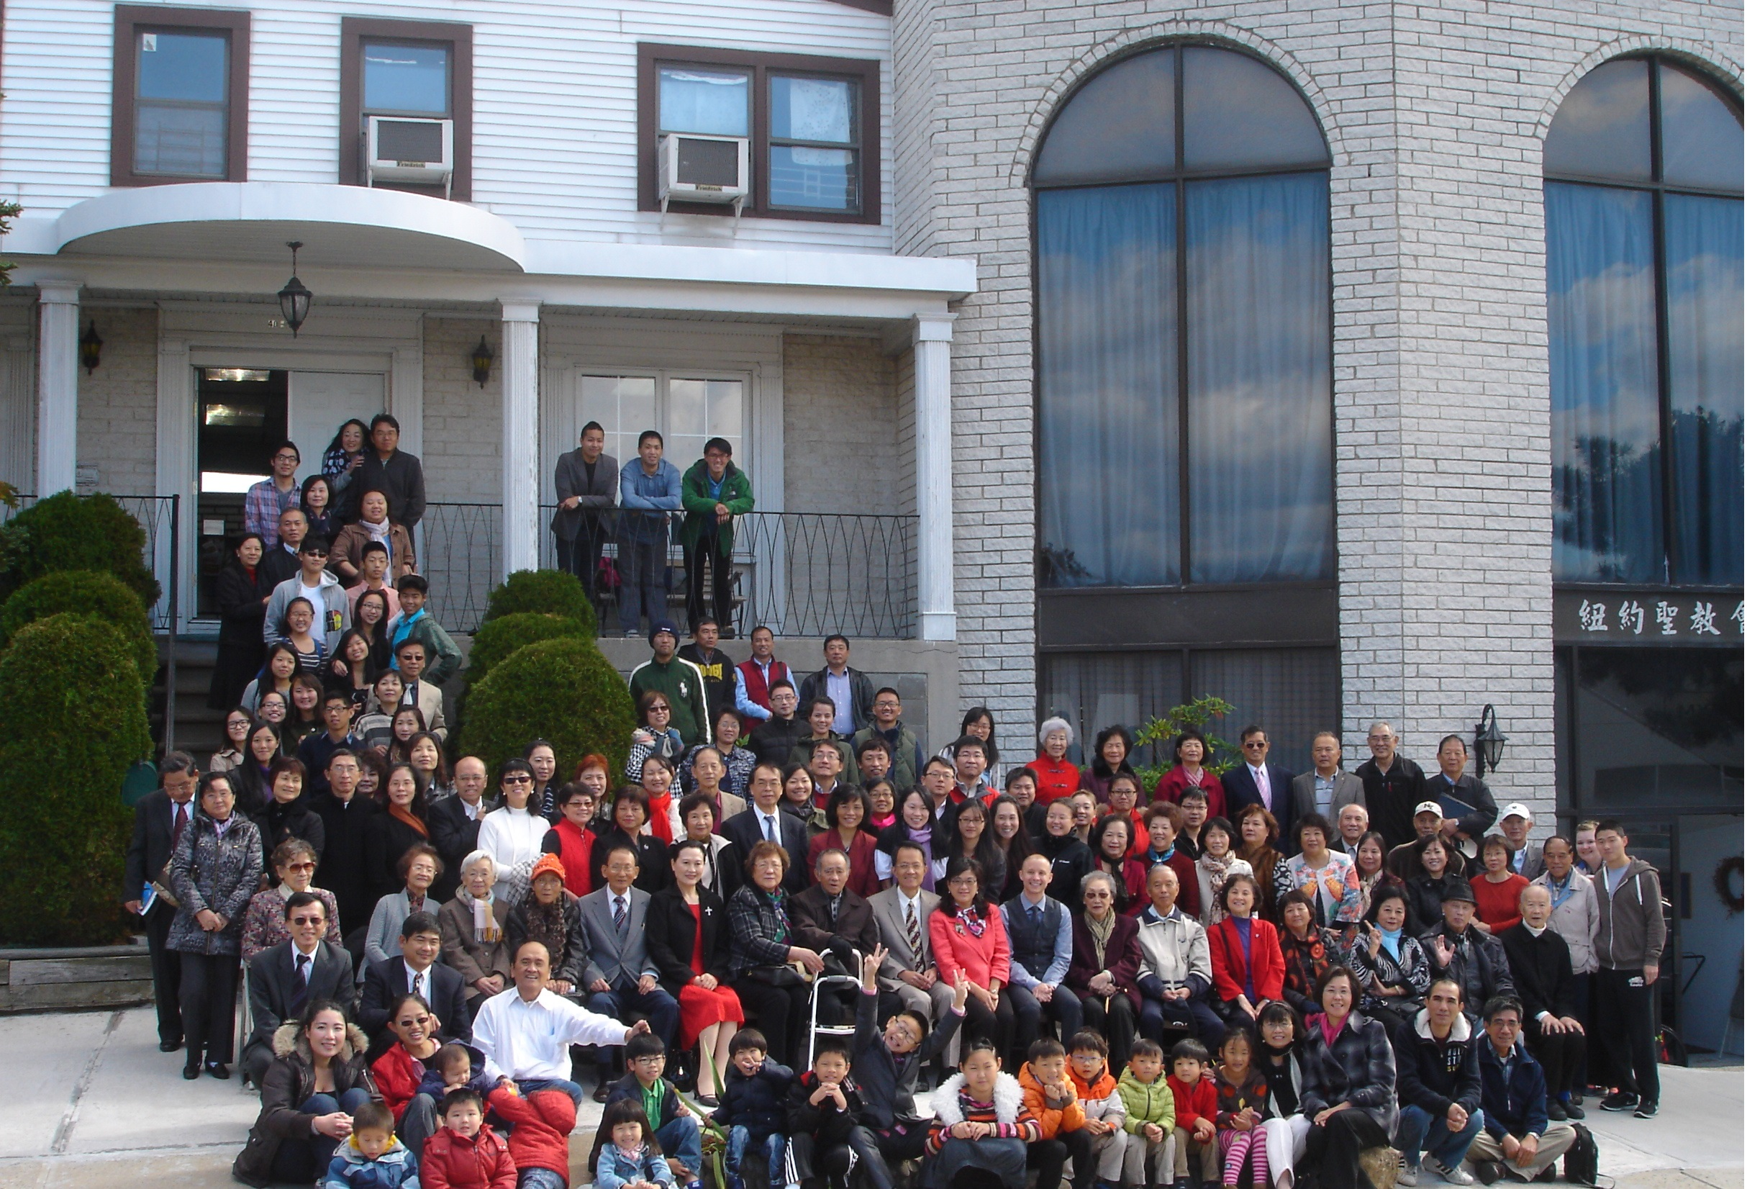

年度金句Key Verse of the Year
歌羅西書Colossians 2:9-10a
「神本性的一切豐盛，都有形有體地住在基督裡面，你們也是在他裡面得了豐盛。」 (新譯本)
「上帝完整的神性攏具體惦佇(tiàm tī)基督內面，恁及(lín kah)祂結聯已經得著豐盛的活命。」(全民台語)
“In Christ the whole fullness of deity dwells bodily, and you have been
filled in him.” (ESV)

榮譽牧師Pastor Emeritus：高耀民牧師Rev. Benjamin Kao
主任牧師Senior Pastor：尤陽生牧師Rev. Johnson Yu, Tel:718-746-4199
英語牧師English Pastor：白書亞牧師Rev. Joshua Birchfield, Tel:970-689-2671
值月同工Coworker of Month：朱駿康Richard Chu, Tel: 646-255-2268
教會地址Church Address：40-31 165th Street, Flushing, NY 11358
教會電話Church Tel：(718)460-6326原網址:qtecny.wtc.net 新網址:qtecnyc.org

紐約聖教會〔復活節主日〕聯合禮拜
QTEC Easter Sunday Combined Worship
第16th wk週 2019/04/21 10:00 AM
司會: 林振成弟兄/李婷姊妹 翻譯:陳鴻成弟兄 司琴:尤立馨姊妹
Pres.: Richard Lin/Christine Li Trans.: Daniel Chen Pianist: Samantha Yu

序樂/Prelude……(會眾安靜默禱 Prayer in Silence)………司琴 Pianist
宣召/Call to Worship………………………………………… 司會Presider
讚美/Songs of Praise……………………英語部敬拜團隊EM Praise Team
1.「醫治者HEALER」 2.「和散那 HOSANNA」
牧禱/ Pastoral Prayer…………Pastor Birchfield白牧師/尤牧師Pastor Yu
啟應文/Responsive Reading …………………………司會/會眾Pres./Cong.
獻詩/Anthem ………「耶穌基督今復活」……………………教會詩班
"Christ the Lord Is Risen Today" Church Choir
讀經/Scripture Reading……「約翰福音John 20:24-29.」………司會Presider
信息/Sermon………“Honest Doubt”…………Pastor Joshua Birchfield
《誠實的懷疑》 …………………白書亞牧師
洗禮/Baptism…………「我的眼睛已經看見」…………尤牧師Pastor Yu
“Mine Eyes Have Seen the Glory”
奉獻/Offertory……「獻己於主」(生命聖詩458首) …黃麗淑Sue H.姐妹
"Take My Life and Let It Be" & 屈耀佳Yao Jia 姐妹
(若你還不瞭解奉獻意義請不必奉獻 Please refrain from offering if you do not understand the meaning)
頌榮/Doxology……「普天之下萬國眾生Doxology」(聖歌29)」…會眾Cong.
祝禱/Benediction………………Pastor Birchfield白牧師/尤牧師Pastor Yu
阿們/Amen………………「阿們頌Amen」………………會眾Cong.
殿樂/Postlude………(會眾安靜默禱Prayer in Silence)………司琴 Pianist
～～～～～～～～～～～～～～～～～～～～～～～～～～～～～～
金句:（約Jn. 20:27-28）(華-新譯/台-全民/E-ESV)
(華M)「耶穌對多馬說：『把你的指頭放在這裡，看看我的手吧！伸出你的手來，探探我的肋旁！不要疑惑，只要信！』多馬對他說：『我的主！我的 神！』」
(台T)「耶穌給多馬講：『伸指頭仔來摸我的手，伸手來摸我的胸坎邊(heng-khám-piⁿ)。呣通憢疑(giâu-gî)，著相信。』多馬應講：『我的主，我的上帝！』」
(E英) 'Jesus said to Thomas, “Put your finger here, and see my hands; and put out your hand, and place it in my side. Do not disbelieve, but believe.” Thomas answered him, “My Lord and my God!”'」
受洗見證、歡迎及報告/Testimony, Welcome & Announcements………司會Presider
【紐約聖教會-各團隊負責同工】Church Co-worker Team
團隊Team | 同工Coworker | 聯絡電話Contact
主席Chairperson | 尤陽生牧師Rev. Johnson Yu | 718-746-4199
副主席Vice Chair | 陳鴻成Daniel Chen | 646-267-3815
英語牧師EM Pastor | Rev. Joshua Birchfield白書亞牧師 | 970-689-2671
行政一Administration 1  行政二Administration 2 | 唐耀鴻Yea Hung Tang  朴真善Jin Parque | 646-309-2997  516-806-0049
敬拜Worship | 劉淑清Samantha Liu | 718-938-2796
關懷Caring | 王積惠Emily Wang  王曉暉Julia Hu | 646-595-6996  646-705-1285
造就Discipleship | 朱駿康Richard Chu | 646-255-2268
事奉Service | 張廣壽William Chang | 917-547-3501
宣教Mission | 陳元卿Ann Chen | 646-828-6658
財務Finance | 陳鴻成Daniel Chen | 646-267-3815
英語部English Ministry | Christine Li李婷 | 718-640-3181
兒童部Children Ministry | 張美琴Megan Chang | 917-566-9006

【小組聚會/活動】Small Groups/Activities
僕人 | 聚會時間 | 聚會地點 | 聯絡電話
長輩喜樂小組-張文雄夫婦 | 週二10:00am | 40-32 166th Street -社區中心 | (646) 427-7040
週五快樂小組 | 週五8:00pm | 40-32 166th Street -社區中心 | (718) 460-6326
社青小組-朱世杰夫婦/一、三週 | 週六7:30pm | 40-31 165th Street -教會三樓 | (917) 566-8602
靈命更新小組/一、三週 | 週六2:00pm | 40-32 166th Street -社區中心 | (718) 460-6326
週六小組/一、三週 | 週六4:00pm | 40-31 165th Street -教會三樓 | (718) 460-6326
桌球練習-林振成弟兄 | 週一,三8-10pm | 週六2-6 pm -教會一樓 | (917) 754-8503

【2019年春季成人主日學】2019 Spring Adult Sunday School
班別/課程內容Class | 教導老師Teacher | 教室Room
早堂華語CM－創世記Genesis | 朱駿康/卓滿莉/張文雄/黃文華/郭慶海/陳元卿/黃麗淑/薛婉華/王秀華/張廣壽/唐耀鴻 | 一樓餐廳
午堂台語TM－創世記Genesis | 簡英仁/陳月華/張俊雄/林振成 | 三樓客廳
慕道班Seekers | 劉淑瓊/王積惠/高如珊 | 三樓客廳
【4/14主日聚會人數】Attendance
早堂崇拜C | 午堂崇拜T | 英文堂崇拜E | 兒童部崇拜CHD | 共計人數TL
63人 人 | 24人 | 21人 | 兒童12人/大3人 | 123人
【4/14/19主日奉獻明細及總計】Offertory Details
十一奉獻
Tithe
感恩奉獻Thanks
建堂Building

其他Others
現金Cash | 十一Tithe | 感恩Thanks | 建堂Building | 其他Others | 總計Total
$413.00 | $ | $ | $ | $ | $

16th wk 04/21/2019 Coworker on Duty: Richard Chu

[Welcome and Announcement]
- Welcome new friends and visitors. May God bless you!

[Pastoral and Co-worker Team]
- There are two people receive baptism today: Jeff Chou and Vicky Zhu. Let's give praise and thanks to God for them!
- The Summer Retreat this year is to be held on July 5-7. Registration will begin from May. Please notice the announcement.
- There is no Sunday school classes on all level. Please join our lunch and fellowship downstairs for sharing and caring.
[Worship Team]
- No choir practice today.
- Be sure to always come to church for Sunday worship 15 minutes before it starts and prepare yourself in God's presence.
[Discipleship Team]
- Current Adult Sunday School schedule for CM/TM is studying Genesis.
- There will be a workshop of Graphical Bible Book Study by Rev. David Su on May 17-18 at the headquarter of Ambassador for Christ.
[Missions Team /Community's Joint Ministries]
- Ping Pong Tournament by FTCCNY will be on Apr. 27 at Taiwan Center.
- Focus on Family summons a rally for 'Respect Life, Protect Life' on May 4 at Time Square. You may contact Rev. Chen through WeChat mmm4him if you'd like to join.
[Administration Team]
- Please cultivate a good habit for recycling classification, make sure of correct recycle classification before disposal.
- Please cultivate a good habit to store or clean up any item you use at church: Bible/bulletin/song sheet/Gospel magazine/devotional, chair/table, coffee mug or cup/soft drink cup, take-out brown bag/shopping plastic bag/lunch box/ kitchen utensil, napkin/paper towel/tissue, pen/paper/scissor/stapler/tape dispenser, umbrella/clothes/shoes/sports equipment/toy, etc.
[Finance Team]
- Building Fund Raising: Personal loan balance from members is $231,000. Our goal is to pay off in 6 years starting from Feb. 2018, with $4,000 payback each month and total $44,000 so far. However the cumulated offering for this fund since Feb. 2018 is only $32,579. So please give your contribution according to what God has blessed you. May the Lord continue to bless you abundantly!
- Building Fund offering update:
Pledge Goal | Cumulated Received (Till 4/07) | Fund Raising-Taiwan(till-4/14) | Pledge Still Needed
$980,000 | $596,406 | $56,200 | $327,394
Monthly Pay Back for Personal Loan |  | Received This Month (Till 4/07)
$4,000 |  | $1,280

- Continue to pray for brother Paul Young's recovery in Bronx hospital. He is waiting to have final minor cosmetic surgery so as to be transferred back to rehab in Queens.
- Continue to pray for the sick and weary in our church family.
～～～～～～～～～～～～～～～～～～～～～～～～～～～
16th wk 04/21/2019 Easter Combined Service
Sermon: “Honest Doubt” Rev. Joshua Birchfield
Scriptures Reading: John 20:24-29

